**Pre-requisites-**

* Docker installed
* Azure Subscription
* Azure CLI installed
* Visual Studio Code (or another code editor)
* Terraform installed
* Git tools installed

Git Repository - https://github.com/aznewgij/servianapp.git

**Deployment steps:**

1. Terraform to deploy the resource group and Azure container registry in the main.tf fileA computer screen capture

   Description automatically generated with medium confidence
2. Git clone <https://github.com/servian/TechChallengeApp.git> to the working directoryText

   Description automatically generated
3. docker pull servian/techchallengeapp:latest

Pull the docker image locally

1. Login to Azure Container Registry (ACR) created earlier.

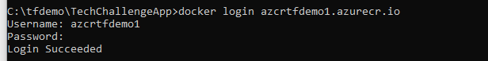

1. Tag the docker image

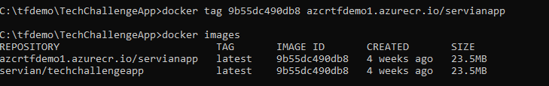

1. Push docker image to ACR

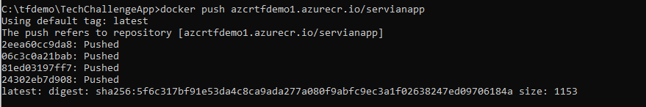

1. Terraform main.tf updated to include the Azure app service plan and app service to deploy web.
2. All required files available in the Git repository - https://github.com/aznewgij/servianapp.git